**KAMPALA PARENTS’ SCHOOL 2004**

**END OF YEAR EXAMINATION, 2018**

**LITERACY 1A – P.3**

**TIME: 2Hrs: 15Mins.**

**NAME____________________________________________STREAM: ___________**

**SECTION A (40 Marks)**

1. Name the main natural source of light and heat on the earth.

_________________________________________________________________________

1. Why do insects visit flowers?

_________________________________________________________________________

1. Write down one example of a crop grown in the swamp.

_________________________________________________________________________

1. Fill in the missing one of the 4Fs.



1. Give one importance of feathers to birds.

__________________________________________________________________________

1. Which part of a sugarcane plant do we eat?

_________________________________________________________________________

1. Give one reason why animals move from one place to another.

__________________________________________________________________________

1. How are spiracles useful to an insect?

_________________________________________________________________________

1. In which season do farmers plant their crops?

__________________________________________________________________________

1. What is wind?

_________________________________________________________________________

_________________________________________________________________________

1. State one way of keeping your classroom clean.

_________________________________________________________________________

1. What do we call an expected danger that can cause harm to the body?

_________________________________________________________________________

1. In the space below, draw and name the garden tool used for cutting down big trees.

___________________________________________________

1. Write down one way of keeping our beddings clean.

_________________________________________________________________________

1. Mention one product got from bees.

_________________________________________________________________________

1. Give one importance of electricity at home.

__________________________________________________________________________

1. Write down one PIASCY message.

__________________________________________________________________________

1. State one way of preventing the spread of malaria.

_________________________________________________________________________

1. Why does a chameleon change its colour?

__________________________________________________________________________

1. Name the body in the sky that reflects light from the sun.

__________________________________________________________________________

1. Mention one group of living things.

__________________________________________________________________________

1. Give one importance of trees in our environment.

__________________________________________________________________________

1. From which plant do we get wool for making clothes?

__________________________________________________________________________

1. 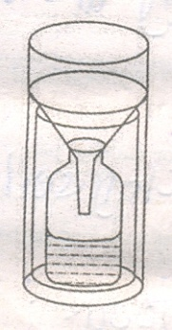Name the weather instrument shown below.

_________________________________________________________

1. Mention one substance used to make ORS.

_________________________________________________________

1. How many legs does a spider have?

_________________________________________________________

1. Give one way you can care for garden tools.

__________________________________________________________________________

1. How is a microscope useful to a doctor?

__________________________________________________________________________

1. State one importance of wild animals to people.

_________________________________________________________________________

1. What do we call insects that live and work together?

_________________________________________________________________________

1. Name the body organ used by a P.3 boy to smell.

_________________________________________________________________________

1. Which type of clouds bring rain?

_________________________________________________________________________

1. 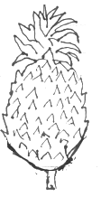Name the fruit shown below.

________________________________________________________

1. Mention one place where rubbish is put after collecting it.

_________________________________________________________

1. Write down any one layer of the soil profile.

_________________________________________________________

1. Give one reason why people eat food.

_________________________________________________________________________

1. 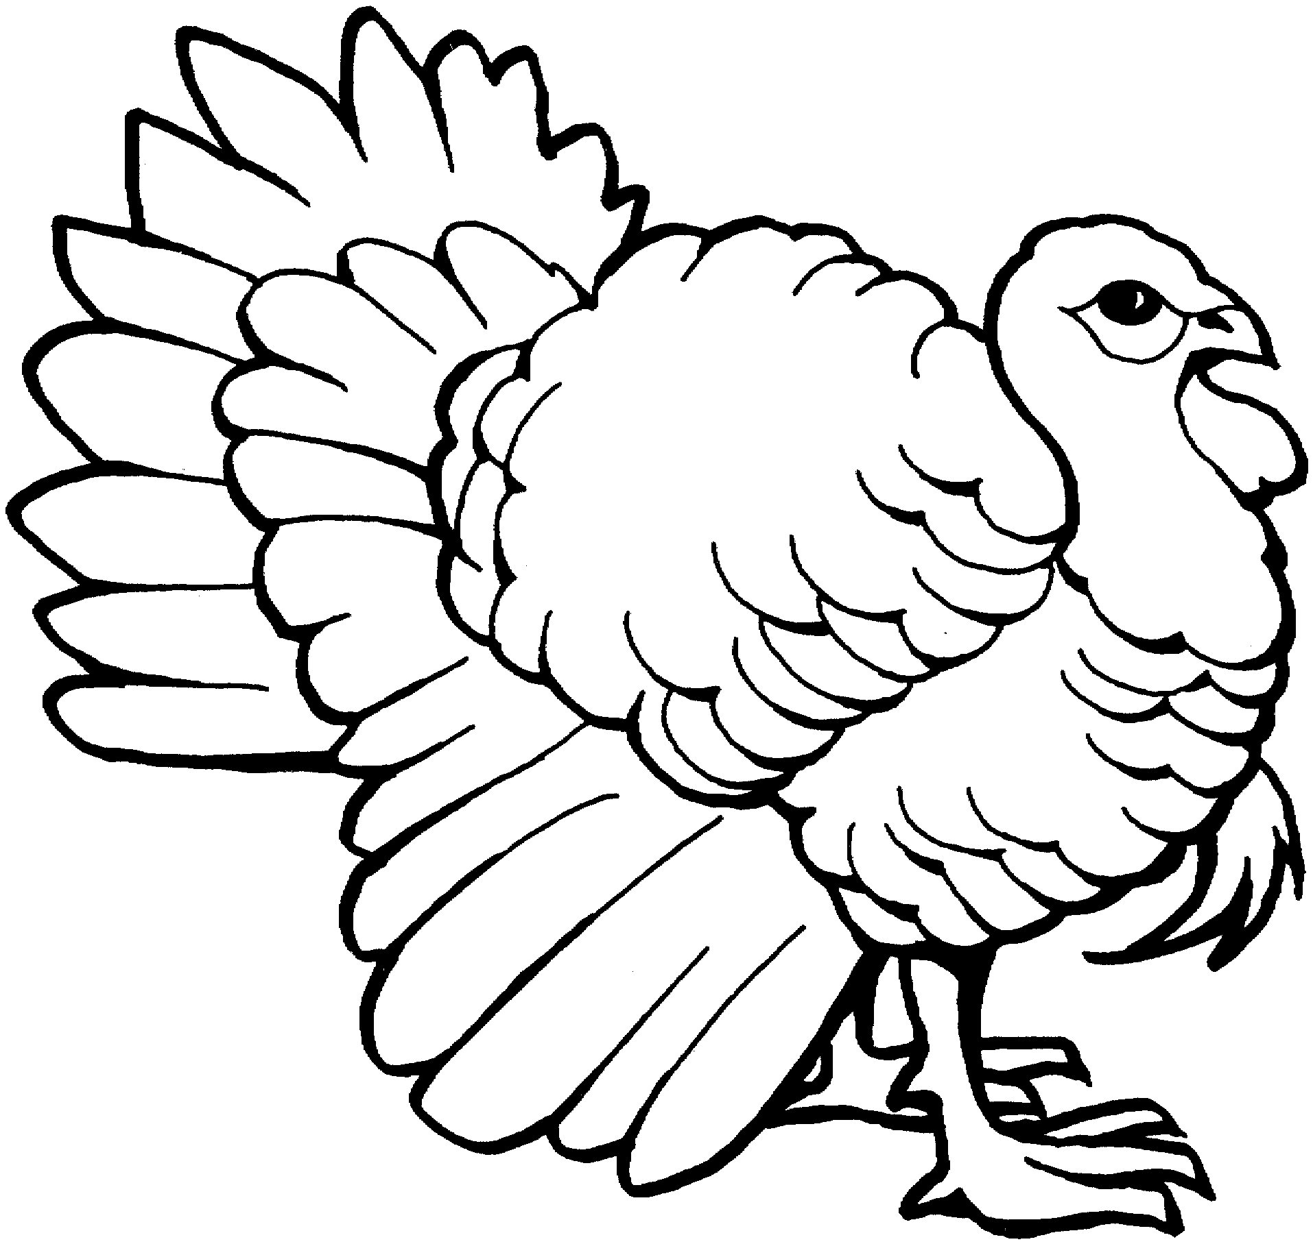Name the domestic bird shown below.

____________________________________________________

1. Give characteristic of non living things.

_________________________________________________________________________

1. Mention one basic need of people.

_________________________________________________________________________

1. What do we call living things which destroy crops?

_________________________________________________________________________

**SECTION B (60 Marks)**

1. a) Mention two systems of a flowering plant.

i)___________________________________ii)____________________________________

b) Give two uses of plants to people.

i) ________________________________________________________________________

ii) ________________________________________________________________________

1. a) A______________________is an oven for baking bricks in order to make them strong.

b) Apart from bricks, mention two other things made out of clay.

i)___________________________________ii)____________________________________

c) What do we call a person who makes things out of wood?

__________________________________________________________________________

1. Name the homes (habitat) of each of the following animals.
2. Weaver birds ______________________________________________
3. Termites ______________________________________________
4. Bee ______________________________________________
5. Dog ______________________________________________
6. Match the following correctly

**A B**

1. chlorophyll Treats teeth
2. HIV The green colour in leaves
3. Dentist Make the soil fertile
4. Humus causes AIDS
5. chlorophyll ______________________________________________
6. HIV ______________________________________________
7. Dentist ______________________________________________
8. Humus ______________________________________________
9. Below are the stages in the life cycle of an insect.

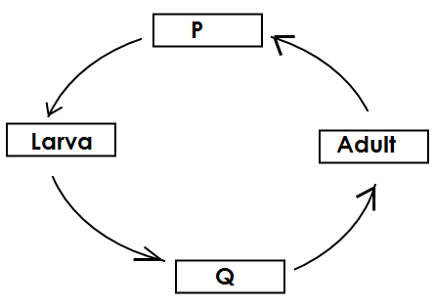a) Name the stages marked with letters P and Q

i) P_______________________________

ii) Q ______________________________

b) Which type of life cycle is shown above?

_________________________________________________________________________

c) Write down one example of an insect with the above life cycle.

_________________________________________________________________________

1. a) What do we call the medicine used for immunisation?

_________________________________________________________________________

b) Apart from polio, mention two other immunisable diseases

i)___________________________________ii)____________________________________

c) State one place a child can be taken for immunisation.

__________________________________________________________________________

1. 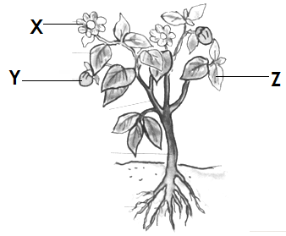The diagram below is of a flowering plant. Use it to answer questions that follow.

a) Name the parts of the plant marked

i) X___________________________________________

ii) Y___________________________________________

b) Give one use of part **Z** to a plant.

____________________________________________________________________________________________

c) Mention one way of caring for plants in the garden.

__________________________________________________________________________

1. a) Write down any two containers used to collect water.

i) ________________________________________________________________________

ii) ________________________________________________________________________

b) Mention two types of weather in which people use an umbrella.

i) ________________________________________________________________________

ii) ________________________________________________________________________

1. 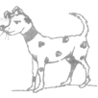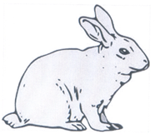Below are two domestic animals. Study them carefully and answer questions about them.

**A B**

a) Identify the domestic animals marked

i) A_________________________________ii) B___________________________________

b) Give one use of the domestic animal marked B above to people.

__________________________________________________________________________

c) State one way of caring for domestic animals.

__________________________________________________________________________

1. a) Write down one group of germs.

_________________________________________________________________________

b) Mention two places where germs can be found.

i) ____________________________________ ii) _________________________________

c) Give one danger of germs to people.

__________________________________________________________________________

1. a) What do we call the growing of a seed into a seedling?

__________________________________________________________________________

b) Write down the three things needed by seeds to grow into seedlings.

i) ___________________________________ii ) __________________________________

iii)___________________________________

1. a) Mention two activities that people do which change our environment.

i) ________________________________________________________________________

ii) ________________________________________________________________________

b) Write down any two natural changes which affect our environment.

i) ________________________________________________________________________

ii) ________________________________________________________________________

1. a) Give one way of preparing each of the following food?

i) Cassava_________________________________________________________________

ii) Meat____________________________________________________________________

b) Mention two ways of preserving food.

i) ________________________________________________________________________

ii) ________________________________________________________________________

1. 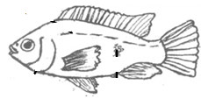The diagram below shows a water animal.

a) Name the water animal shown above.

____________________________________________________

b) How does the above water animal move?

__________________________________________________________________________

c) Write down two other animals that live in water.

i) __________________________________ ii)____________________________________

1. a) Mention two components of air.

i) __________________________________ii)____________________________________

b) Write down two properties of air.

i) ________________________________________________________________________

ii)________________________________________________________________________

**Merry Xmas & Happy New Year 2019*****